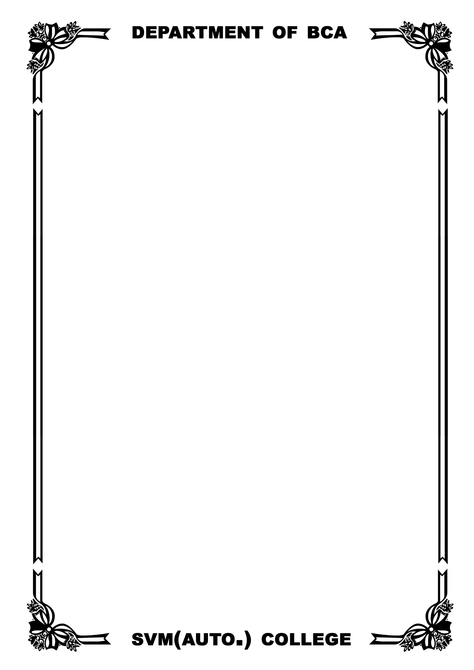**CONTENT PAGE**

|  |  |
| --- | --- |
| **Sl. No** | **Content** |
| **1** | Hardware Specification |
| **2** | Software Specification |
| **3** | Introduction |
| **4** | Propose of project |
| **5** | Project Abstract |
| **6** | ATM Banking Module |
| **7** | Starting Page Design |
| **8** | Creating database with MS-ACCESS |
| **9** | Coding |
| **10** | Conclusion |

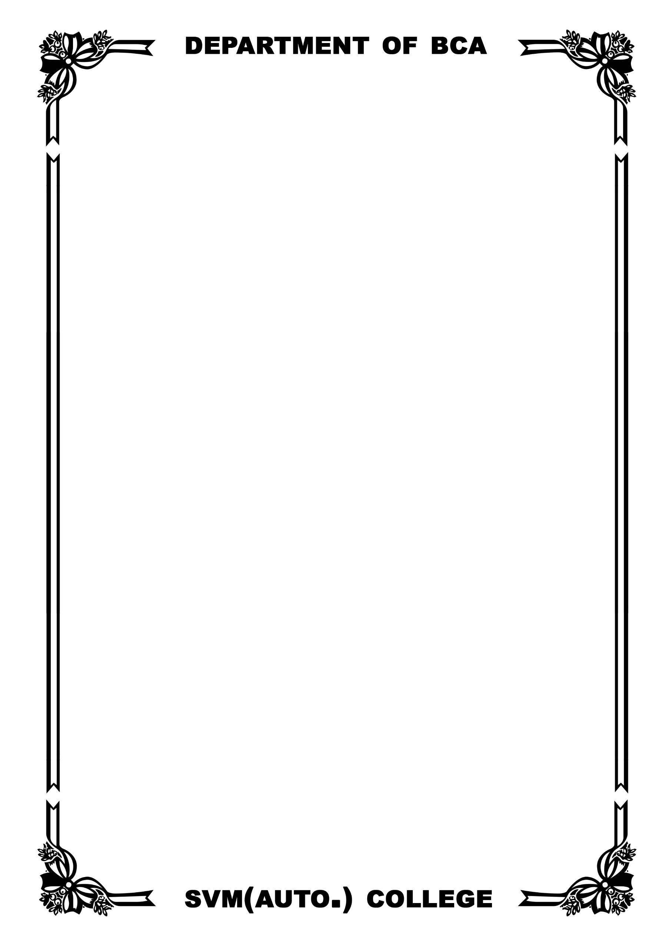

**HARDWARE SPECIFICATION**

* **IBM Compatible PC hardware requirements.**

|  |  |
| --- | --- |
| CPU | 486 or Higher, any speed |
| Main Memory | Minimum 8 MB  Recommended – 16 MB |
| Display | Color required minimum 256 colors  Recommended 16K colors in better configured for 640 X 480 or larger |
| Printer | Not-required |
| Disk Space | Only that required for installation of browser |

* **Macintosh hardware requirments**

|  |  |
| --- | --- |
| CPU | 486 or Higher, any speed |
| Main Memory | Minimum 8 MB  Recommended – 16 MB |
| Display | Color required minimum 256 colors  Recommended 16K colors in better configured for 640 X 480 or larger |
| Printer | Not-required |
| Disk Space | Only that required for installation of browser |

**SOFTWARE SPECIFICATION**

**Operating system (Any)**

* Windows operating system.
  + Version. Windows-XP or higher.
* Macintosh
  + Version: 7 or Later
* Unix Os.

**Application Software**

* Microsoft visual Studio .Net
* Database management system (Ms-Access).

**Introduction:-**

The Automated Tailor Machine is an automatic banking machine which allow costumer to complete basic transaction without any help of Bank, representatives.

There are two types of ATM. The Basic one allows the customer to allow cash and another one is more complex machine which accepts the deposit, provides Credit card payment facilities, and reports account information.

My project is basic ATM banking system which draws only cash and receive a report of account balance.

**Project Abstract:**

At present banking process is becoming easier and Customer are saving time for checking balance withdraw money from any location using ATM machine ,check, reset transaction .etc. In developing this architecture software and hardware application are designed.

In this project we designed as ATM banking system project for understanding operations that are involved in.

**Purpose of Project: -**

ATM banking system is a banking software Application developed in Asp.Net Now ATM Stands for automated trailer machine. It is widely used in all over the world to perform various Banking software various banking Operation. With this ATM banking software various task done by a typical Bank management application can be done such as:

* Adding customer detailed
* Viewing customer cash withdrawal/deposited details.
* Managing Banking account
* Generating pin
* Mini statement
* Printing report and many more

ATM software and added money features that are present in present ATM software.

**ATM Banking Module:**

**Admin Login:** Admin should enter user name and

Password for using software.

**Create Customer**: - This form is useful for entering new user record to database. We can enter Name, address, email id, contact, card no., pin no, city, account number and balance.

**View Customer Details**: - Information of customer account is visible in this module. We have to user bank account number to view details.

**Add Account Details**:-This form consists of account number, Name, current balance, credits fields Customer Transaction details by entering customer bank account number details of recent transactions are displayed with time of transaction amount and account number.

X

**Creating ATM Project with MS-Access with VB.Net:-**

**Form design:-**

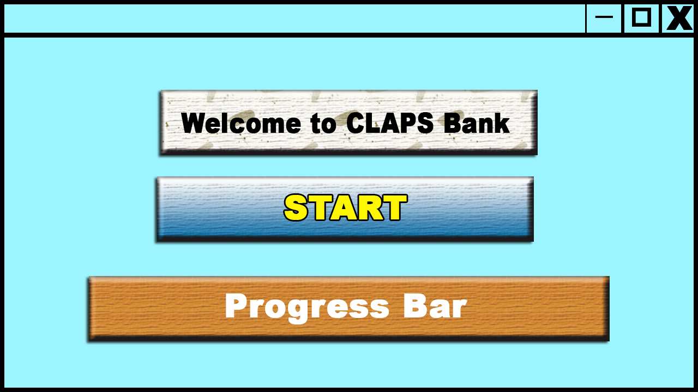

**Code for Timer event:**

import javax.swing.*;

import java.awt.event.*;

public class Form1 {

private Timer timer1;

private JProgressBar progressBar1;

private JButton button1;

public Form1() {

timer1 = new Timer(1000, new ActionListener() {

public void actionPerformed(ActionEvent e) {

progressBar1.setValue(progressBar1.getValue() + 1);

if (progressBar1.getValue() == progressBar1.getMaximum()) {

progressBar1.setValue(0);

timer1.stop();

progressBar1.setVisible(false);

button1.setEnabled(true);

}

}

}

}

}

private void form1_Joad(Object sender, EventArgs e) {

super.load();

progressBar1.setMaximum(100);

progressBar1.setMinimum(0);

timer1.start();

}

private void button1_Click(Object sender, EventArgs e) {

Form2.show();}

**Window form2:-**

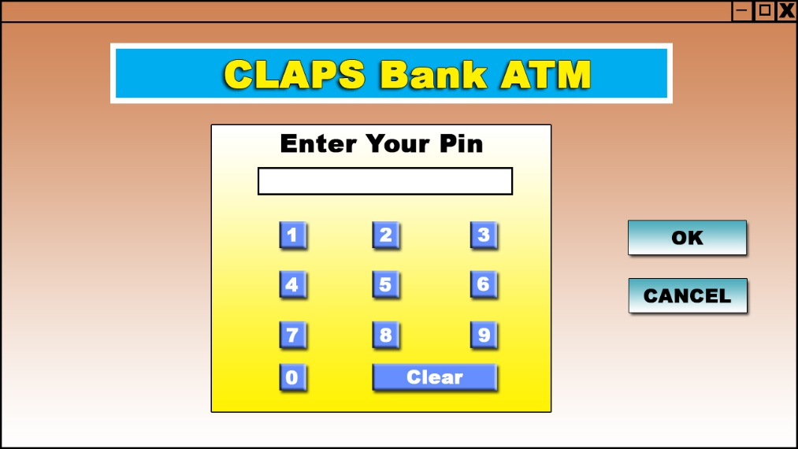

**MS-ACCESS:-**

* Open MS-Access.
* Getting started window will be displayed.
* Click on blank database button.
* In the right-hand side panel in the database file name give the file name ATM.
* Click on create button.
* The ATM database window will be displayed.
* In the left hand side, all tables pan right click on table 1: table icon and in the shortcutmenu select the option design view.
* The save as dialog box appear.
* Give the table name pin do and click on ok button.
* Then table structure window will be displayed.
* Create the following field.

|  |  |  |
| --- | --- | --- |
| Field name | Data type | Size |
| Pin | Text | 4 |
| Acc-no | Text | 20 |

Go to the form and activate the load event and type the following code.

import java.sql.*;

import javax.swing.*;

public class Form2 extends JFrame {

private int inc;

private Connection con;

private String dbprovider, dbsource, sql;

private DataSet ds;

private OleDbDataAdapter da;

private int maxrows;

public Form2() {

dbprovider = "jdbc:ucanaccess://d:/latm.mdb";

dbsource = "";

con = DriverManager.getConnection(dbprovider + dbsource);

sql = "SELECT * FROM atm";

da = new OleDbDataAdapter(sql, con);

ds = new DataSet();

da.fill(ds, "atm");

maxrows = ds.Tables("atm").getRowCount();

}

private void button1_Click(object sender, EventArgs e) {

int searched, i, currentrow;

searched = Integer.parseInt(textBox1.getText());

i = 0;

while (i < maxrows + 1) {

if (searched == Integer.parseInt(ds.Tables("atm").getValue(i, "pin"))) {

this.dispose();

Form3.label1.setText(ds.Tables("atm").getValue(i, "acc-no"));

Form3.show();

break;

} else if (i == maxrows) {

JOptionPane.showMessageDialog(null, "Invalid pin number!!");

break;

}

i++;

}

currentrow = i;

}

}

X

**Window Form3:-**

**Code for clear button:-**

Private sub button3_click (byval sender As System.object.Byval e as system.EventArgs)

Handels

TextBox1.Text=""

TextBox1.clear ()

End sub

**Code for Cancel Button-**

private void Button2_Click(System.EventArgs Sender) {

Form1 form1 = new Form1();

form1.Show();

this.Close();}

**Select 1,2,3,4,5,6,7,8,9,0 button**

**Write the following code for the buttons**

import java.awt.event.ActionEvent;

import java.awt.event.ActionListener;

import javax.swing.*;

public class MyClass {

private JTextField textBox1;

public MyClass() {

textBox1 = new JTextField();

JButton btn1 = new JButton();

btn1.addActionListener(new ActionListener() {

public void actionPerformed(ActionEvent e) {

textBox1.setText(textBox1.getText() + btn1.getText());

}

});

JButton btn2 = new JButton();

btn2.addActionListener(new ActionListener() {

public void actionPerformed(ActionEvent e) {

textBox1.setText(textBox1.getText() + btn2.getText());

}

});

JButton btn3 = new JButton();

btn3.addActionListener(new ActionListener() {

public void actionPerformed(ActionEvent e) {

textBox1.setText(textBox1.getText() + btn3.getText());

}

});

JButton btn4 = new JButton();

btn4.addActionListener(new ActionListener() {

public void actionPerformed(ActionEvent e) {

textBox1.setText(textBox1.getText() + btn4.getText());

}

});

JButton btn5 = new JButton();

btn5.addActionListener(new ActionListener() {

public void actionPerformed(ActionEvent e) {

textBox1.setText(textBox1.getText() + btn5.getText());

}

});

JButton btn6 = new JButton();

btn6.addActionListener(new ActionListener() {

public void actionPerformed(ActionEvent e) {

textBox1.setText(textBox1.getText() + btn6.getText());

}

});

JButton btn7 = new JButton();

btn7.addActionListener(new ActionListener() {

public void actionPerformed(ActionEvent e) {

textBox1.setText(textBox1.getText() + btn7.getText());

}

});

JButton btn8 = new JButton();

btn8.addActionListener(new ActionListener() {

public void actionPerformed(ActionEvent e) {

textBox1.setText(textBox1.getText() + btn8.getText());

}

});

JButton btn9 = new JButton();

btn9.addActionListener(new ActionListener() {

public void actionPerformed(ActionEvent e) {

textBox1.setText(textBox1.getText() + btn9.getText());

}

});

JButton btn0 = new JButton();

btn0.addActionListener(new ActionListener() {

public void actionPerformed(ActionEvent e) {

textBox1.setText(textBox1.getText() + btn0.getText());

}

});

}

}

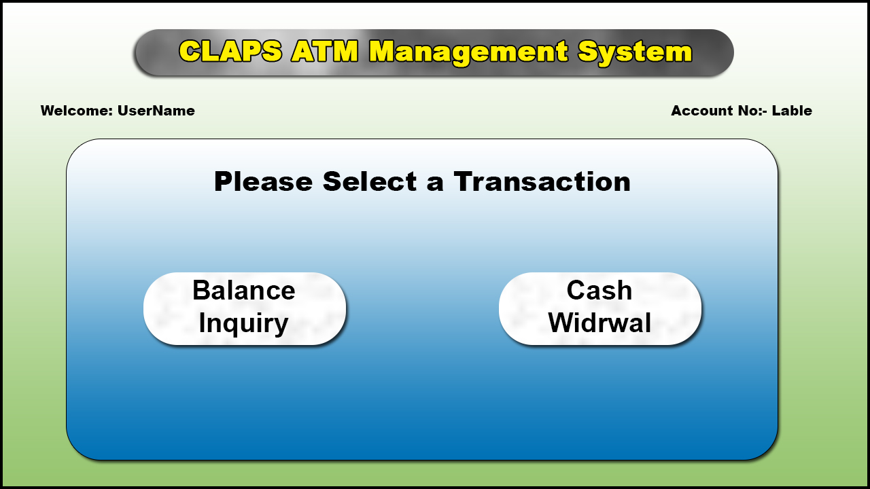

**Code Form Form3:-**

import java.sql.*;

import javax.swing.*;

public class Form3 extends JFrame {

private int Inc;

private Connection con;

private String dbprovider, dbSource;

private Dataset ds;

private oleDb.oleDbDataAdapter da;

private String sql;

private int Maxrows, currentrow;

private void Form3_Load(Object sender, System.EventArgs e) {

dbprovider = "jdbc:ucanaccess://";

dbSource = "C:/users/public/lvidoslatn.accdb";

con = DriverManager.getConnection(dbprovider + dbSource);

sql = "SELECT * FROM Master";

da = new oleDb.oleDbDataAdapter(sql, con);

ds = new Dataset();

da.fill(ds, "atm");

Maxrows = ds.Tables("atm").getRowCount();

int i = 0;

while (i < Maxrows + 1) {

if (lable1.getText().equals(ds.Tables("atm").getValue(i, "acc-no"))) {

Lable4.setText(ds.Tables("atm").getValue(0, "cuts-name"));

Form4.Lable1.setText(ds.Tables("atm").getValue(i, "cuts-name"));

Form4.Lable2.setText(ds.Tables("atm").getValue(i, "acc-no"));

break;

} else if (i == Maxrows) {

JOptionPane.showMessageDialog(null, "ADMIN User");

break;

}

i++;

}

currentrow = 1;

}

}

**CREATE MASTER TABLE IN MS-ACCESS:-**

**Structure Of Master Table**

|  |  |
| --- | --- |
| Field Name | Data Type |
| Acc-No | Text |
| Address | Text |
| Mobile-no | Text |
| Occp | Text |
| Date opened | Date/Time |
| Acc-Type | Text |
| Amnt | Text |
| Pin | Number |

**Coding For Button1:-**

Private Sub Button1-Click (Byval Sender As System.Object, Byval e As System.Event Args)Handless Button

Form4.Show 0

End Sub

**Window Form4:-**

**Form4 Coding:-**

Import System. Data. Sqlcient

Imports System. Data

Public class form4

Dim inc As integer

Dim Con As New oldb. oledb connection

Dim db provider, dbsource As String

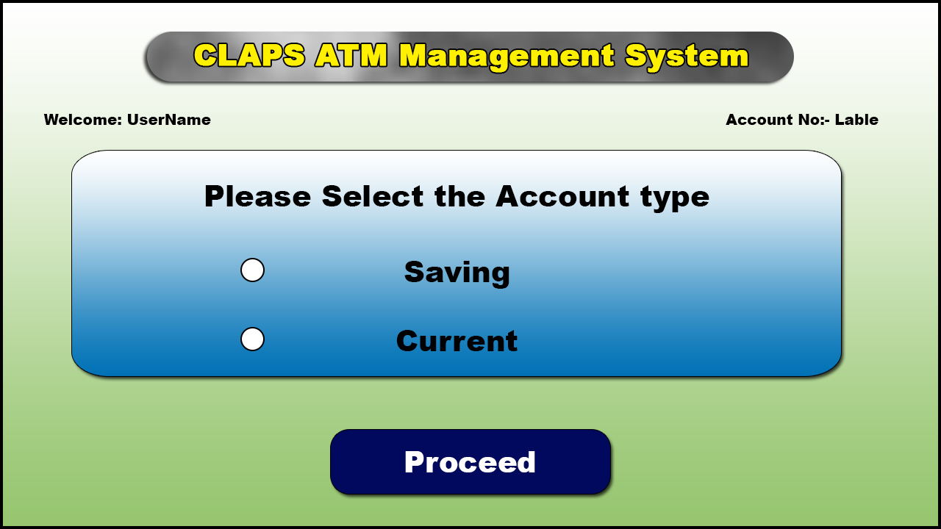

Dim da As New dataset

Dim da As New OleDb. OleDb data Adapter

Dim Sql As String

Dim MaxroWs, 1, Current row As integeger

Private sub form4-Load(Byval Sender As System Object, Byval Cas System,EventArgs)Handles MyBase,Load.

dbprovider="Provider=MicrosoftACE.OLEDB.12.0"

dbsource="Data Sourcec:\users\publiclvideoslatm.accdh

con.connectionstring=dbprovider and dbsource con.open()

sql="sELECT A FORM Master

da=New oleDb.oleDbDataAdapter(sql.con)

da.Fillds, atm")

Maxrowsds.Tables(atm).RoWs.count

I=0

While ik>maxrows+

IF Label2.Text=ds.Tables("atm"). Rows()("acc-no")Then

Label1.Text=ds.Tables('atm").Rows(0( cust-name")

Label6.Text-Dst. Tables("atm).Rows()('acc-no)

Form5.Label3.Text=ds.Tables('atm ).Rows(0('cust-name')

Form5.Label6.Text=ds.Tables("atm").Rows(t)("acc-no)

Exit While

ELSEIF =Maxrows Then

MSBOX ("ADMIN USER)

Exit While

End if

i+=1

End While

Currentrow=i

End sub

XX

**Window Form5:-**

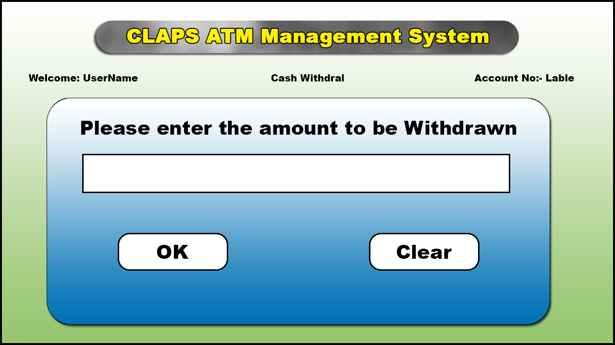

Imports system .data. sqlctient

Impors system. data

Public class form

Dim Inc As integer

Dim con As new olDb. oleDb connection

Dim dbprovider, dbsource As sting

Dim ds, ds1 As New Dataset

Dim da, da1 As New Oledb. OleDbData Adapter

Dim sql,sql1,srw As string

Dim Maxrows, mr ,I, current rowAs integer

Public balance, current As Integer

Dim dot As date

Private sub form5-load(BYval Sender As system. Object, Byval e As system. Event Args)

Handle MyBase. Load

Db provider="provider=Microsoft.ACE. OLEDB.12.0";

Db source "Datasource=c:lusers lpubliclvideoslatm.accdb

Con.Connection String= dbprovider & dbsource

Con.open)

Sql = "Select From Master

Sql1="Select From dailytrans

Da=New oledb.oleDb Data Adapter(sql1,con)

Da1= New oledb. oleDbData Adapter(sql1,com)

Da.fllds,'atm

Da1. Fill(ds 1,'atm)

Maxrows= ds.tables(atm). Rows. Count

Mr = ds1. Tables("atm").rows.count

End sub

**Create Master Table:-(Daily transfer)**

|  |  |
| --- | --- |
| **Data Name** | **Data Type** |
| Dataoftrans | Date/Time |
| Acc-No | Text |
| Transtype | Text |
| Amtwd | Currency |
| Prevent | Currency |
| Curr amt | Currency |

**For - OK :-**

**Code For Current:-**

Private sub button1dlick(Byval sender As system.object.Byval e As system. EventArgs) fandles Button

Dim 1, Current row As lInteger

While io Maxrows+1

If Lable2. Text= ds. Tables("'atm). Rows()

(“aco-no”) Then Current= ds. Tables('atm").Rows

(i)(amnt) balance=current- TextBox.Text

Daily()

Dim cb As New oleDb. OleDbcommandBuilder(da)

Ds.table/atm).Rows(), Item("'amnt")=balance

Daupdate(ds,'atm)

MsgBox(amount withdrawed")

Exit while

Else if iF Maxrows then

MsgBox"Invalid PIN number!!")

Exit while

End if

It=1

End while

Currentrow=1

End sub

End class

XX

**Code for Saving:-**

Dim cb1 As New oleDbcommand Builder(da1)

Dim ds New Row As DataRow

dsNew Row ds1.Tables("atm"). NewRow)

f Form4. RadioButton1.Checked= True Then

Srw=From4.RadioButton1.Text

Else

Srw-From4.RadioButton2.Text

End if

Dot-Datatime.now

dsNewRow.ltem('dateof trans"J=dot

dsNewRow Item('acc-no=Lable6.Text

dsNewRow.litem("transtype"=srw

dsNewRow.ltem("'atm wD")=TextBox1.Text

dsNewRow. Item('prevent)=Current

dsNewRow.ltem("Current)=balance

ds 1.Tables (atm").Rows.adddsNewRow)

da1.Update(ds1, 'atm)

MsgBox("daily transaction update")

End sub

**Code For cancel:-**

Private sub Button2_ click(Byval Sender As system. Object, Byval e As system. Event Args)

Handles Button

Me.close()

Form3.show()

End sub

End class

**Code For Main Menu:-**

Private sub LinkLable1_ Linkcliked (Byval sender As system.object,BYval e As

system.windows. Forms)

Me. Close)

Form3.showWO

End.showo

End sub)

End class

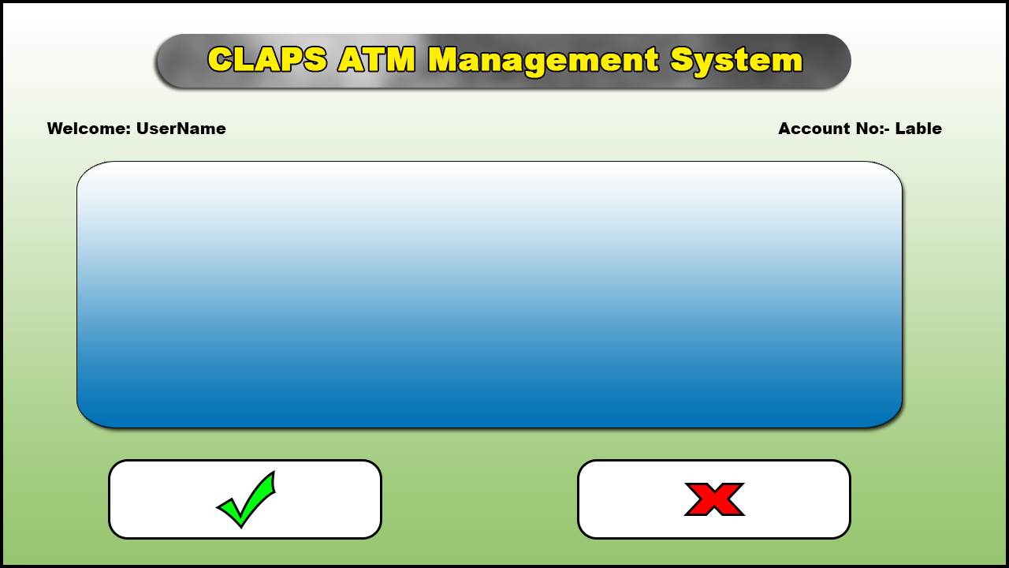

import java.sql.*;

import java.util.*;

public class Fom11 {

int inc;

Connection con;

String dbUrl, dbUser, dbPass;

ResultSet rs;

Statement stmt;

String sql;

int maxRows, currentRow, l, c;

ArrayList<ArrayList<String>> data = new ArrayList<ArrayList<String>>();

public Fom11() {

dbUrl = "jdbc:odbc:Driver={Microsoft Access Driver (*.mdb)};DBQ=C:\\mydatabase.mdb;";

dbUser = "";

dbPass = "";

try {

Class.forName("sun.jdbc.odbc.JdbcOdbcDriver");

con = DriverManager.getConnection(dbUrl, dbUser, dbPass);

stmt = con.createStatement(ResultSet.TYPE_SCROLL_SENSITIVE, ResultSet.CONCUR_UPDATABLE);

sql = "SELECT * FROM mytable";

rs = stmt.executeQuery(sql);

while (rs.next()) {

ArrayList<String> row = new ArrayList<String>();

row.add(rs.getString("column1"));

row.add(rs.getString("column2"));

row.add(rs.getString("column3"));

data.add(row);

}

maxRows = data.size();

currentRow = 0;

displayRow();

} catch (Exception e) {

System.err.println("Error: " + e);

}

}

public void displayRow() {

ArrayList<String> row = data.get(currentRow);

for (int i = 0; i < row.size(); i++) {

System.out.print(row.get(i) + " ");

}

System.out.println();

}

public static void main(String[] args) {

Fom11 f = new Fom11();

}

}

private void From6(Object sender, EventArgs e) {

String dbprovider = "Provider=Microsoft.Ace.Oldbe.12.0";

String dbsource = "Data source=c:luserslpubliclvideoslatrm.accdb";

con.connectionString = dbprovider + dbsource;

db.open();

da.Fill(ds, "atm");

int Maxrows = ds.Tables("atm").Rows.Count;

int i = 0;

while (i != Maxrows + 1) {

if (Label1.Text.equals(ds.Tables("atm").Rows(0)("acc-no"))) {

DataView dv = new DataView(ds.Tables("o"), "acc-no='" + Label6.Text + "' and acc-no");

DataGridview1.DataSource = dv;

break;

} else if (i == Maxrows) {

MessageBox("ADMIN USER");

break;

}

i++;

}

Currentrow = i;

}

import javax.swing.JOptionPane;

private void button1_click(ActionEvent e) {

JOptionPane.showMessageDialog(null, "your transaction completed");

}

private void button2_Click(Object sender, EventArgs e) {

this.dispose();

Form3 form3 = new Form3();

form3.setVisible(true);

}

**FUTURE IMPROVEMENTS**

Due to lack of time and limited resources we have implemented a Small version of "BMS". In the near future we have planned to improve the project on the following aspects:

* Presently our project has been implemented in an intranet environment, which can be enhanced to a larger domain i.e. internet in near future .By doing so a website of internet banking with payment transactions can be launched, to which people from all over the world will have access.
* We will implement ASP.NET technology in our project to make server side programming. But with use of advanced technology along with ASP.NET, the speed of processing can be increased by many folds.
* Cookies can be implemented in our project, which helps in faster accessing on the client side.
* With time we can enhance our present database for accommodating more number of transactions.
* In our project uploading facilities can be added which will enable a person to enable his own transactions on to the website.
* In near future we can add other facilities for users benefit.